Name : Sahil Saini Salaria
Reg No. 180905048
Roll No. 11C
Batch C1

Q0

#include <mpi.h>
#include<stdio.h>

int main(int argc, char *agrv[])
{
int rank,size;

MPI_Init(&argc,&agrv);
MPI_Comm_rank(MPI_COMM_WORLD,&rank);
MPI_Comm_size(MPI_COMM_WORLD,&size);

printf("Rank :%d \t Size :%d\n",rank,size);

MPI_Finalize();

return 0;
}

// mpicc prog0.c -o prog && mpirun -np 4 ./prog

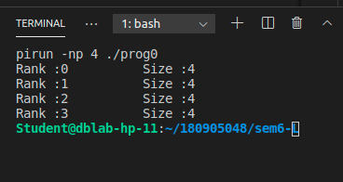

Q1

#include<mpi.h>
#include<stdio.h>
#include<math.h>

int main(int argc,char *argv[])
{
const int x=3;
int rank;

MPI_Init(&argc,&argv);
MPI_Comm_rank(MPI_COMM_WORLD,&rank);
printf("Rank %d\n",rank);

int p=pow(x,rank);
printf("power(%d,%d): %d\n",x,rank,p);

MPI_Finalize();

return 0;

}

// mpicc prog1.c -lm -o prog1 && mpirun -np 4 ./prog1

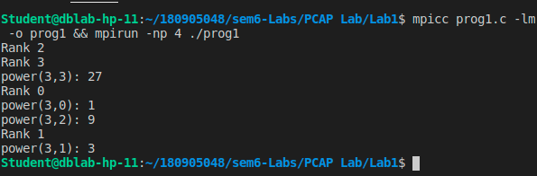

Q2

#include<mpi.h>
#include <stdio.h>

int main(int argc, char *agrv[])
{
int rank;

MPI_Init(&argc, &agrv);
MPI_Comm_rank(MPI_COMM_WORLD, &rank);

if (rank % 2 == 0)
{
printf("Hello\t Rank :%d \n", rank);
}
else
{
printf("World\t Rank :%d \n", rank);
}

MPI_Finalize();

return 0;
}

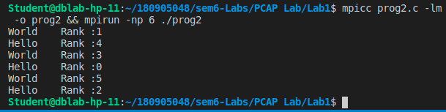

Q3

#include<mpi.h>
#include<stdio.h>
#include<math.h>

int main(int argc,char *argv[])
{
const int num1=3,num2=4;
int res=0;
int rank;

MPI_Init(&argc,&argv);
MPI_Comm_rank(MPI_COMM_WORLD,&rank);

if(rank==0)
{
printf("Addition of (%d , %d): %d\n",num1,num2,num1+num2);
}
else if (rank==1)
{
printf("Multiplication of (%d , %d): %d\n",num1,num2,num1*num2);
}
else if(rank==2)
{
printf("Division of (%d , %d): %f\n",num1,num2,(float)num1/(float)num2);
}
else if(rank==3)
{
printf("Subtraction of (%d , %d): %d\n",num1,num2,num1-num2);
}

MPI_Finalize();

return 0;

}
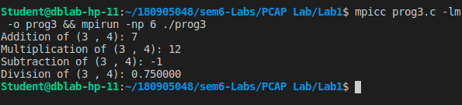

Q4
#include <mpi.h>
#include <stdio.h>

int main(int argc, char *argv[])
{
char arr[6] = {'H', 'e', 'L', 'L', 'O', '\0'};
int rank;
MPI_Init(&argc, &argv);
MPI_Comm_rank(MPI_COMM_WORLD, &rank);

if (arr[rank] >= 65 && arr[rank] <= 90)
{
arr[rank] += 32;
}
else
{
arr[rank] -= 32;
}
printf("rank %d After %s\n", rank, arr);
MPI_Finalize();

return 0;
}

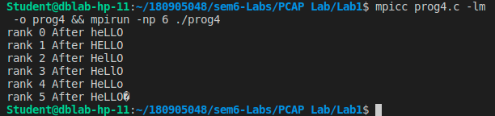

Additional Q1

#include <mpi.h>
#include <stdio.h>
#include <math.h>

int reverse(int num)
{
int rev = 0;
while (num)
{
int rem = num % 10;
rev = rev * 10 + rem;
num /= 10;
}
return rev;
}

int main(int argc, char *argv[])
{
int arr[9] = {18, 523, 301, 1234, 2, 14, 108, 150, 1928};
int rank;
int rev;

MPI_Init(&argc, &argv);
MPI_Comm_rank(MPI_COMM_WORLD, &rank);

arr[rank] = reverse(arr[rank]);

printf("Rank %d\t%d\n", rank,arr[rank]);

MPI_Finalize();

return 0;
}

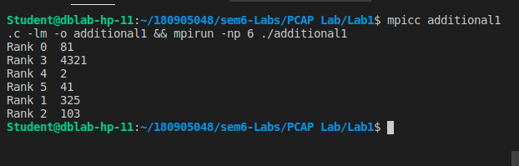

Additional Ques 2

#include <mpi.h>
#include <stdio.h>
#include <math.h>

int isPrime(int num)
{
for (int i = 2; i*i <= num; i++)
{
if(num%i==0)
return 0;
}
return 1;
}

int main(int argc, char *argv[])
{
int rank;

MPI_Init(&argc, &argv);
MPI_Comm_rank(MPI_COMM_WORLD, &rank);

if(rank==0)
{
for (int i = 2; i <=50; i++)
{
if(isPrime(i))
{
printf("%d ",i);
}
}

}
else{
for (int i = 50; i <=100; i++)
{
if(isPrime(i))
{
printf("%d ",i);
}
}

}

MPI_Finalize();

return 0;
}
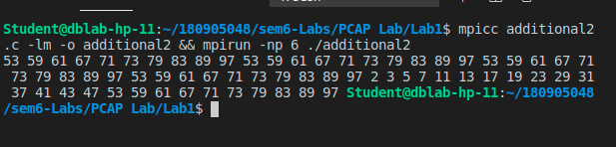

//////////////////////////////////////////////////////////Ends/////////////////////////////////////////////////////////////////

